**How to Use Generative AI for Protecting Sensitive Data and Improve Operations**

Micah Neal & Yilake Mengstie

Bowie State University

CTEC 445

Fall 2024

1. Introduction 2

2. Problem Statement 3

3. The Broader Impacts 3

4. Purpose of the Research 3

5. Case Study 4

6. Methodologies 4

Method 1: Data Pattern Analysis 5

Method 2: Anomaly Detection 5

Method 4: Data Encryption Support 7

Method 5: Automated Report Generation 8

Method 6: AI-Driven Alerts and Notifications 8

Method 7: Threat Simulation 9

References 12

1. Introduction

Generative AI has emerged as a transformative technology that not only boosts operational efficiency but also offers advanced solutions for securing sensitive data. By using machine learning models to generate new content, generative AI can automate tasks, enhance decision-making processes, and even aid in identifying potential threats. Organizations today face increasing challenges in data security, making the integration of generative AI a critical tool for protection (Darktrace, 2024).

Moreover, with the rise in cyberattacks and the expansion of digital networks, protecting sensitive data has become paramount. Generative AI algorithms can analyze vast amounts of data to detect patterns and anomalies that signify potential risks. This ability not only improves security measures but also streamlines operations, allowing organizations to focus on core activities rather than manual security checks.

# 2. Problem Statement

The protection of sensitive data has become increasingly complex with the rise of cyber threats. Traditional security measures often fall short in identifying and mitigating sophisticated attacks. The integration of generative AI provides a new solution by automatically detecting vulnerabilities and protecting critical information. This research aims to explore how generative AI can be effectively used to protect sensitive data while simultaneously improving organizational operations (Poeppelbuss & Koenig, 2019).

3. The Broader Impacts

The broader impacts of using generative AI for data protection go beyond just security enhancements. It allows for operational efficiency, reducing human errors in manual processes, and improving overall productivity (Darktrace, 2024). In addition, as AI continues to evolve, organizations can adopt AI-driven policies for data compliance, ensuring regulations like GDPR are met. These advancements not only safeguard company data but also promote trust and transparency with customers (Poeppelbuss & Koenig, 2019).

## 4. Purpose of the Research

The purpose of this research is to explore the various ways generative AI can protect sensitive data and improve operational processes. By investigating the technological mechanisms behind generative AI, this research will demonstrate how organizations can use this technology to stay ahead of cyber threats while enhancing the efficiency of their daily operations.

5. Case Study

Darktrace, a leading cybersecurity firm, has leveraged artificial intelligence to address the challenges posed by increasingly sophisticated cyber threats and the limitations of traditional monitoring systems (Darktrace, 2024). Their AI-powered solution, known as the Enterprise Immune System, utilizes self-learning algorithms to establish a baseline of normal behavior across users, devices, and networks (Darktrace, 2024). This system continuously monitors network activity to detect anomalies that deviate from the established baseline, which may indicate potential security threats. Notably, Darktrace’s AI can autonomously respond to detected threats by isolating affected systems and alerting security teams, significantly enhancing the speed and effectiveness of threat management (Darktrace, 2024). The implementation of this technology has resulted in improved threat detection capabilities, reducing response times from hours to minutes and enabling proactive defense measures (Darktrace, 2024). For instance, Darktrace’s AI successfully identified and contained a sophisticated phishing attack at a major global financial institution (Darktrace, 2024). This example underscores the transformative impact of AI on data protection, offering a robust solution for real-time threat detection and automated response.

## 6. Methodologies

### Method 1: Data Pattern Analysis

Generative AI uses data pattern analysis to identify potential threats to sensitive data. By learning from historical data, it creates models that can detect anomalies that signify risks. This method ensures that any irregularities in the data flow, such as unauthorized access, are immediately flagged for further inspection (Poeppelbuss & Koenig, 2019).

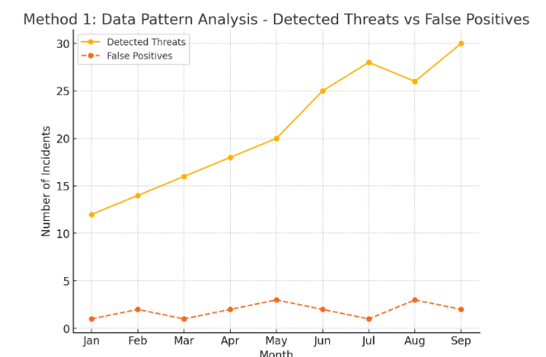

**Fig1**: The graph shows the number of detected threats and false positives across different months. The steady increase in detected threats with some fluctuations in false positives illustrates the effectiveness of AI in identifying potential risks over time.

### Method 2: Anomaly Detection

Generative AI can be trained to recognize anomalies within a data set. By continuously monitoring system activities, it can detect outliers or unexpected behaviors that could indicate a data breach. This method ensures real-time protection of sensitive data by identifying potential threats before they occur (Poeppelbuss & Koenig, 2019).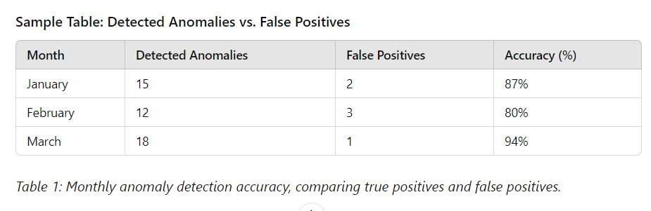Method 3: Automation of Risk Management

One of the key methodologies for improving operations is the automation of risk management tasks using generative AI. By automating tasks like compliance checks, threat analysis, and system monitoring, organizations can significantly reduce the time spent on manual security procedures (Poeppelbuss & Koenig, 2019).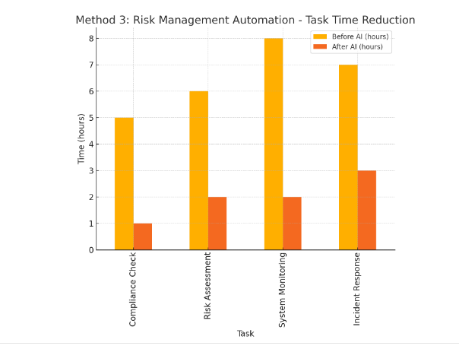

**Fig2:** The bar graph compares the time taken to complete risk management tasks (such as compliance checks and system monitoring) before and after AI automation. Significant time reductions are observed, showing how automation improves efficiency.

### Method 4: Data Encryption Support

Generative AI models can assist in improving encryption algorithms by predicting potential vulnerabilities and optimizing encryption protocols. This ensures that sensitive data remains secure both during storage and transmission, making it harder for unauthorized users to access information (Poeppelbuss & Koenig, 2019).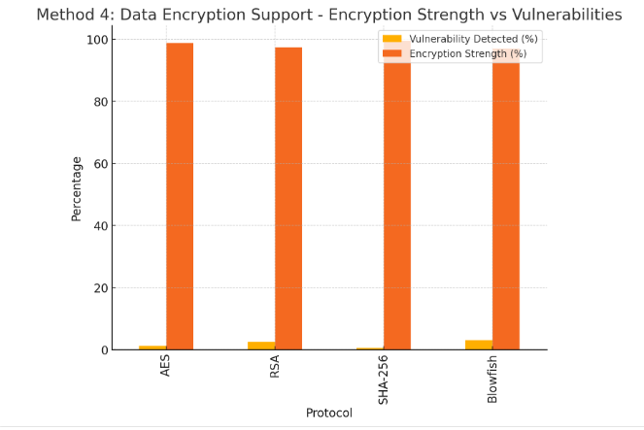

**Fig3:** The bar graph compares different encryption protocols' vulnerability detection rate and encryption strength. This graph highlights the balance between security strengths and potential weaknesses in protocols like AES and RSA.

### Method 5: Automated Report Generation

Generative AI can automatically generate reports detailing security incidents, detected vulnerabilities, and operational insights. This not only helps improve the decision-making process but also streamlines the documentation required for audits and compliance checks (Goodfellow et al., 2014).

### Method 6: AI-Driven Alerts and Notifications

Generative AI can enhance the alert system by identifying high-priority incidents and notifying relevant teams immediately. By doing so, the response time is improved, and the organization can quickly mitigate risks (Poeppelbuss & Koenig, 2019).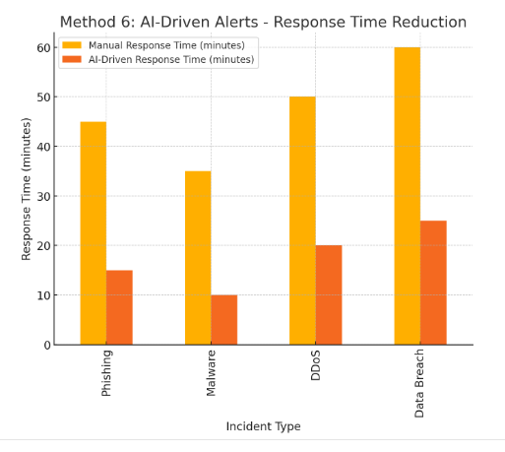

**Graph 4**: The graph compares the manual and AI-driven response times for various incident types. AI systems drastically reduce response times, emphasizing their role in improving the speed of incident management.

### Method 7: Threat Simulation

Generative AI can simulate potential cyberattacks on the system, testing how well the current security measures hold up. This helps organizations identify weaknesses in their security architecture and improve defensive mechanisms accordingly.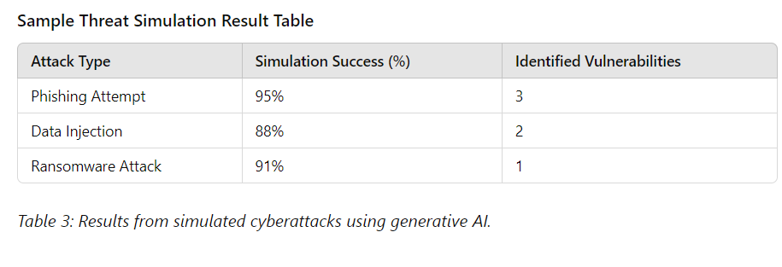Method 8: Workflow Optimization

Generative AI also contributes to workflow optimization by automating routine operational tasks, allowing employees to focus on more critical strategic activities. By doing this, organizations improve their overall productivity and reduce the chance of human error in manual processes (Goodfellow et al., 2014).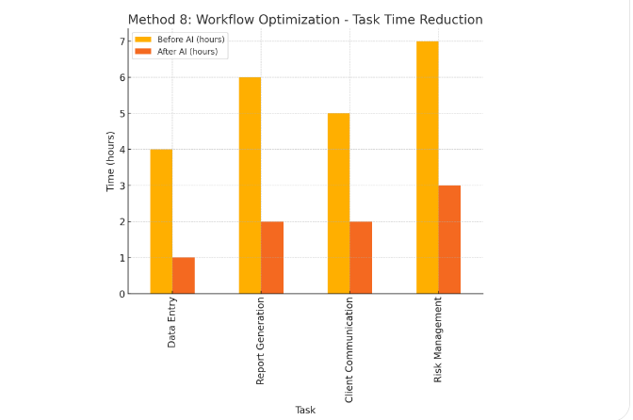**Graph 4:** The bar graph for Method 8: Workflow Optimization illustrates the significant reduction in task completion times after the integration of AI-driven optimization. Tasks such as data entry, report generation, client communication, and risk management all show improved efficiency, with time reductions across the board.

Generative AI has proven to be a transformative technology in enhancing data security and operational efficiency. By leveraging advanced models like Generative Adversarial Networks (GANs) and anomaly detection, organizations can proactively identify and mitigate cyber threats, safeguarding sensitive information more effectively. Additionally, AI-driven automation streamlines routine tasks, reduces human errors, and boosts overall productivity. Integrating generative AI improves immediate security and operational processes and contributes to broader benefits such as regulatory compliance and increased customer trust. As AI technology continues to advance, it offers even greater potential for optimizing data protection and operational efficiency. Organizations that embrace these innovations will be better equipped to navigate the evolving digital landscape and secure their operations against emerging threats.

## References

1. Darktrace. (2024). *Case Studies*. Retrieved from <https://www.darktrace.com/en/resources/case-studies/>
2. Darktrace. (2024). *AI Technology Overview*. Retrieved from <https://www.darktrace.com/en/technology/>
3. Goodfellow, I., Pouget-Abadie, J., Mirza, M., Xu, B., Warde-Farley, D., Ozair, S., ... & Bengio, Y. (2014). Generative adversarial nets. *Advances in Neural Information Processing Systems, 27*, 2672-2680.
4. **Poeppelbuss, J., & Koenig, W. (2019).**  
    AI in operations management: Current state and future directions. *Journal of Business Economics, 89*(1), 55-87. <https://doi.org/10.1007/s11573-019-00951-4>
5. **Sarker, I. H. (2021).**  
    Machine learning: Algorithms, real-world applications, and research directions. *SN Computer Science, 2*(3), 160. <https://doi.org/10.1007/s42979-021-00592-x>